We are pleased to offer you the following machine:

Date: September 24, 2023
SACMA SP 350 M
5-Station 4-Die Progressive Header
Catalog Specifications:  - Max. cutoff dia 15 mm  - Max. cutoff length 127 mm  - Max. shank length 90 mm  - punch ko length 29,3 mm  - Production rate 200 ppm  - Main drive 45 kW | 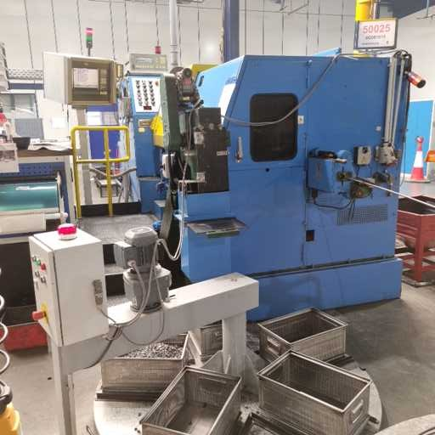
Please contact Tecma GmbH for more information | Built by: Sacma, Limbiate, Italy  Year: 1995  Model: SP-350M

Prezzo speciale Germania......................................................................…… 280.000 €
NOTE: An effort has been made to assure the above specifications are accurate; however, it is the sole responsibility of the buyer to confirm the actual model, serial number, capacity, attachments, age, and condition. We urge all buyers to inspect the machinery before purchase.
If you have any questions or require additional information, please do not hesitate to contact me.
Very truly yours,
IVAR
TECMA GMBH

